Task 1
Windows Server Installation & Virtualization Setup

Objective: Install Windows Server (e.g., Windows Server 2022) in a virtual machine using Oracle VM VirtualBox or VMware, configure base system parameters, and capture the initial desktop screen after successful administrator login.
1. Virtual Machine Configuration Specifications:

Parameter | Configuration Setting | Description
Hypervisor Software | Oracle VM VirtualBox (v7.x) | Virtualization Environment
Guest Operating System | Windows Server 2022 Standard (Desktop Experience) | Target OS Image
Assigned RAM | 4096 MB (4 GB) | Dedicated Virtual Memory
Processor Cores | 2 Virtual CPUs | Processing Power
Virtual Hard Disk | 50 GB (Dynamically Allocated VDI) | Storage Partition
Network Adapter | NAT / Bridged Adapter | Network Connectivity

2. Step-by-Step Installation Procedure:
1.VirtualBox Setup:Step 1: Create New VM.
- Open VirtualBox, click New, name it Windows-Server-2022, and select the Windows Server ISO image.

- Allocate 4096 MB RAM and 2 CPU Cores. Create a 50 GB virtual hard disk.
2.OS Installation:Step 2: Boot & Setup Wizard.
- Start the VM and boot from the ISO. Select Language, Time/Currency format, and Keyboard layout.

- Click Install Now and select Windows Server 2022 Standard (Desktop Experience) for GUI access.
3.Disk Setup:Step 3: Partitioning & File Copy.
- Choose Custom: Install Windows only (advanced), select the unallocated 50 GB disk partition, and proceed with file copying.
4.Initial Boot:Step 4: Administrator Password & First Login.
- After system reboot, set a strong Administrator password (e.g., Admin@12345).

- Log in using Ctrl + Alt + Del (VirtualBox Input menu) and enter your credentials.
3. Post-Installation Verification:
Upon successful administrator login, the Server Manager Dashboard launches automatically alongside the desktop:

OS Name: Microsoft Windows Server 2022 Standard
System Model: VirtualBox Virtual Machine
Processor: Intel(R) Core(TM) i5/i7 (2 vCPUs)
Installed RAM: 4.00 GB

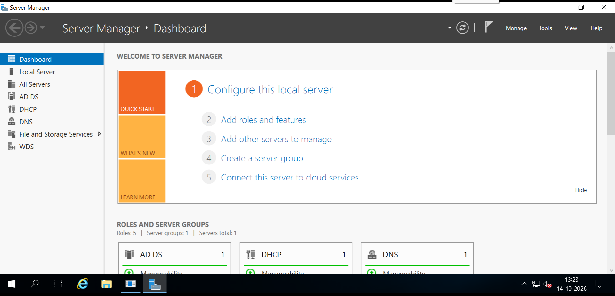

Task 2
Active Directory Domain Services (AD DS) Role Installation & Domain Promotion

Objective: Open Server Manager on Windows Server, install the Active Directory Domain Services (AD DS) role, and promote the server to a new Domain Controller with the domain name foodiefans.local.

1. Step-by-Step Configuration Guide:
1.Server Manager Configuration:Step 1: Install AD DS Role.
- Open Server Manager on Windows Server.

- Click on Add roles and features.

- Proceed through the wizard until the Server Roles selection screen.

- Check the box for Active Directory Domain Services and click Add Features, then complete the installation.
2.Post-Deployment Configuration:Step 2: Promote Server to Domain Controller.
- Once installation completes, click the yellow warning flag icon at the top of Server Manager and select Promote this server to a domain controller.

- In the Deployment Configuration wizard, select Add a new forest.

- Enter the root domain name: foodiefans.local and click Next.
3.DC Options & Reboot:Step 3: Set DSRM Password & Complete Promotion.
- Enter a secure Directory Services Restore Mode (DSRM) password.

- Proceed through DNS delegation warnings and path confirmations, then click Install.

- The server will automatically restart to finalize promotion as a Domain Controller.

Task 3
Creating Organizational Units (OUs) in Active Directory

Objective: Open Active Directory Users and Computers (ADUC) and create three Organizational Units (OUs) named 'Influencers', 'FoodReviewers', and 'BrandPartners' under the foodiefans.local domain.
1. Step-by-Step Execution Procedure:
- Open Server Manager $→$ Click Tools $→$ Select Active Directory Users and Computers (ADUC).
- Expand the domain foodiefans.local in the left console tree.
- Right-click on foodiefans.local $→$ Hover over New $→$ Click Organizational Unit.
- Type name Influencers and click OK.
- Repeat the exact same steps to create the remaining two OUs:
  - FoodReviewers
  - BrandPartners

Task 4
Creating User Accounts Inside the 'Influencers' OU

Objective: Create two new user accounts inside the 'Influencers' OU named 'foodiequeen' and 'spicyking', setting a secure password for each.
1. Step-by-Step Execution Procedure:
- In Active Directory Users and Computers, expand foodiefans.local and click on the Influencers OU.
- Right-click inside the empty space on the right pane $→$ Hover over New $→$ Click User.
- For User 1 (foodiequeen):
  - First name / Full name: foodiequeen
  - User logon name: foodiequeen
  - Click Next, enter a secure password, uncheck "User must change password at next logon" (for lab ease), and click Finish.
- For User 2 (spicyking):
  - Repeat the process with user logon name: spicyking, set the password, and click Finish.

Task 5
Business Application of Organizational Units (OUs) for Enterprises (Zomato / Swiggy)

Objective: Write a short explanation of how Organizational Units in Active Directory help companies like Zomato or Swiggy manage employee access and permissions efficiently.
Enterprise Use-Case Explanation:
Organizational Units (OUs) allow food-tech giants like Zomato or Swiggy to logically structure their massive workforce (e.g., Delivery Operations, Marketing Influencers, Tech Support, and Finance) mirroring corporate hierarchy. By organizing user accounts and computers into specific OUs, IT administrators can effortlessly apply targeted Group Policy Objects (GPOs)—such as restricting software installations for delivery partners or enforcing strict data access controls for finance teams. This modular grouping ensures streamlined permission management, enhanced security compliance, and centralized administrative control across regional branch offices.

